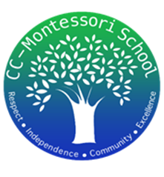
Treasurer’s Report
1/31/2024

We began this month with the following balances:

- Checking account $8,088.10
- Petty Cash $200.00

- Deposits:
  - $415.84 T-shirts & Pizza Fundraisers
  - $216.30 Charleston Wrap Online Fundraiser
  - Total Income: $632.14

- Payments:
  - $162.36 Provided lunch for NCI kids for their trip
  - $188.80 Cleaning supplies (to be reimbursed by MAST)
  - $151.83 Pizza & Hot Lunches Expenses
  - $1,420.45 T-shirts Purchase
  - Total Expenses: $1,923.44

Total Net Loss in January: -$1,291.30

At the end of the month, the ending balances were as follow:
- Checking account $6,796.80
- Petty Cash $200.00

