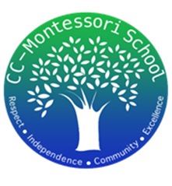
Treasurer’s Report
9/30/2025
We began this month with the following balances:
- American Bank & Frost Bank Checking accounts $23,675.08
- Petty Cash $200.00

- Deposits:
  - $43.29 School Supplies Refund
  - $1,355.00 Pizza donations
  - $160.00 T-shirt donations
  - $80.30 Popcorn donations
  - $212.40 Chick-Fil-A dinner night out Fundraiser
  - Total Income: $1,850.99

- Payments:
  - $10.83 Merchant Fees (to accept credit card & Venmo pmts)
  - $490.90 Pizza cost
  - $20.00 Bank Fee
  - $16.18 Subscription Fee
  - $2,500.00 Certificate of Deposit
  - Total Expenses: $3,037.91
Total Net Loss in September: -$1,186.92
At the end of the month, the ending balances were as follow:
- Checking accounts: $22,488.16
- Certificate of Deposit: $2,500.00 {90 day, 3.05%)
- Petty Cash $200.00

