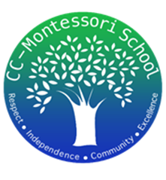
Treasurer’s Report
3/29/2024

We began this month with the following balances:

- Checking account $7,424.21
- Petty Cash $200.00

- Deposits:
  - $425.00 T-shirts sales
  - $844.00 Pizza sales
  - $38.78 MAST reimbursements
  - Total Income: $1,307.78

- Payments:
  - $697.91 Pizza fundraiser cost
  - $24.51 Merchant Fees (to accept credit card & Venmo pmts)
  - $151.32 School supplies cost to be reimbursed by MAST
  - Total Expenses: $873.74

Total Net Profit in March: $434.04

At the end of the month, the ending balances were as follow:
- Checking account $7,858.25
- Petty Cash $200.00

