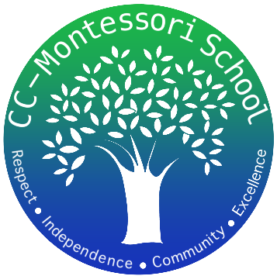
Corpus Christi Montessori School
A Free Public Charter

822 Ayers Street
Corpus Christi, Texas
(361) 852-0707
www.cc-montessori.com
Aftercare Lead
School Contact: Ada Flores Email: ada@cc-montessori.org

Title- Aftercare Lead

Salary- $15.00 based on experience

Duty Days- 183 Monday-Thursday 4:00-5:30 Friday 12:30-5:30

Start Date- August 9th, 2023

Subject Area/Teaching Field Endorsement/Requirements
- An effective communicator with students, parents/guardians, colleagues, and others both verbally and in writing.
- CPR and First Aid up to date,
- Collaborative in nature/a team player.
- Confident.
- Flexible.
- Personable.
- Excellent planning and organizational skills.
- Willing to work alongside an associate.
- Maintain proximity to students while outside.
- Build plans to enrich students time after school until students are picked up by parents or until 5:30 pm.

Description
School Year 2023-2024
Aftercare Lead – Multi-aged group setting 1st-8th graders.
The lead will be responsible for planning engaging activities for students in their time afterschool. They will be responsible for the safety and dismissal of students when parents/guardians come to pick them up.
The ideal candidate will feel comfortable working and building relationships with students from all different backgrounds in a flexible learning environment. They will be willing to spend time outdoors with students for academic and play/team building purposes.

Application available online:
https://www.cc-montessori.com/employment
Close Date
Open until filled
Qualifications:
- Excellent organizational skills.
- Demonstrate a positive work attitude and can establish and maintain excellent relationships with staff, parents, and students.
- Ability to maintain a peaceful environment.
- Maintain and initiate appropriate protocols in response to incidents/accidents and behavior.
- Follow the Montessori philosophy and methodology of “children come first”.
- Be kind and respectful to the children.
- Work closely and collaboratively with other staff as needed.
- Strong work ethic with excellent communication and presentation skills.
Creative, inspirational, self-directed, positive, and committed with a “can-do attitude”.
- Willing to learn from and work well with fellow faculty members.

Benefits:

- Competitive Salary
- Paid Personal, Sick and Teacher Workdays
- TRS Retirement Plan
- Health Insurance Opportunities
- Professional Development Opportunities
- Positive and Friendly Staff
- Small community feeling
- Supportive Parents
- Respectful Students
- Safe Working, Pleasant and Flexible Environment
- Montessori Training Opportunities
- Subscription to American Montessori Society.

