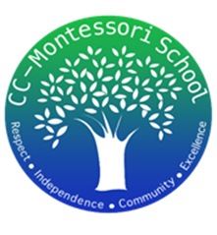
Treasurer’s Report
8/31/2025
We began this month with the following balances:
- American Bank Checking account $7,853.46
- Frost Bank Checking account $13,580.00
- Petty Cash $200.00

- Deposits:
  - $4,700.10 School Supplies Donations
  - $72.73 School Supplies Refunds
  - $965.00 Pizza donations
  - $341.00 T-shirt donations
  - $15.00 PTO Membership Donation
  - Total Income: $6,093.83

- Payments:
  - $96.27 Merchant Fees (to accept credit card & Venmo pmts)
  - $1,622.00 T-shirts cost
  - $2,083.94 School supplies expense
  - $50.00 Sam’s renewal fee
  - Total Expenses: $3,852.21
Total Net Profit in August: $2,241.62
At the end of the month, the ending balances were as follow:
- Checking accounts $23,675.08
- Petty Cash $200.00

