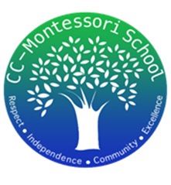
Treasurer’s Report
7/31/2025
We began this month with the following balances:
- American Bank Checking account $16,261.26
- Frost Bank Checking account $1,000.00
- Petty Cash $200.00

- Deposits:
  - $4,210.22 School Supplies Donations
  - $169.00 Pizza late payments
  - $240.00 T-shirt donations
  - $25.00 Crawfish ticket to go to MAST
  - Total Income: $4,644.22

- Payments:
  - $37.80 Merchant Fees (to accept credit card & Venmo pmts)
  - $917.94 Student Appreciation Day expenses
  - $378.97 Pizza cost
  - $13.48 School supplies expense
  - Total Expenses: $1,348.19
Total Net Profit in July: $3,296.03
At the end of the month, the ending balances were as follow:
- Checking accounts $21,433.46
- Petty Cash $200.00

